ISO 27035 Compliance for Log360
Strengthen cybersecurity and meet ISO 27035 compliance with Log360.
Region: International | Type: Industry Standard, Incident Management | Category: Compliance | Pricing: Free

Overview
The ISO 27035 compliance extension in Log360 helps organizations meet ISO/IEC 27035, the international standard for information security incident management covering preparation, detection, reporting, assessment, response, and lessons learned phases (Parts 1-4, 2023-2024) by providing centralized log management, real-time incident detection, and audit trail preservation. The platform supports ISO 27035 requirements for incident planning, event detection, incident assessment, response and containment, evidence preservation, post-incident review, and coordination.
For Incident Management Planning and Preparation, Log360 enables this phase by collecting policy change events, GPO enforcement logs, backup readiness reports, and system event baselines to validate pre-incident preparedness. To address Incident Detection and Event Reporting, the platform aggregates antivirus alerts, network attack reports, threat detection events, and Unix security alerts to ensure all potential incidents are captured and escalated for assessment. The extension also supports Incident Assessment and Decision Making by providing capabilities that provides detailed system event logs, process tracking records, registry change history, and firewall activity to support accurate incident severity triage and classification.

Key Features
- Incident Response and Containment: Log360 monitors failed logon spikes, account lockouts, network attack events, and firewall rule changes to support containment actions and verify that response measures are effective.
- Evidence Collection and Forensic Preservation: Log360 captures detailed event logs, database audit trails, process execution histories, and application server logs to provide a tamper-evident audit trail that supports forensic analysis.
- Post-Incident Review and Lessons Learned: Log360 generates audit reports on GPO enforcement, policy changes, user account activity, and system events to support root-cause analysis and validate security improvements after incidents.
- Incident Management Coordination: Log360 monitors network device logs, cross-system attack data, firewall events, and shared network activity to support coordinated incident response across organizational and platform boundaries.


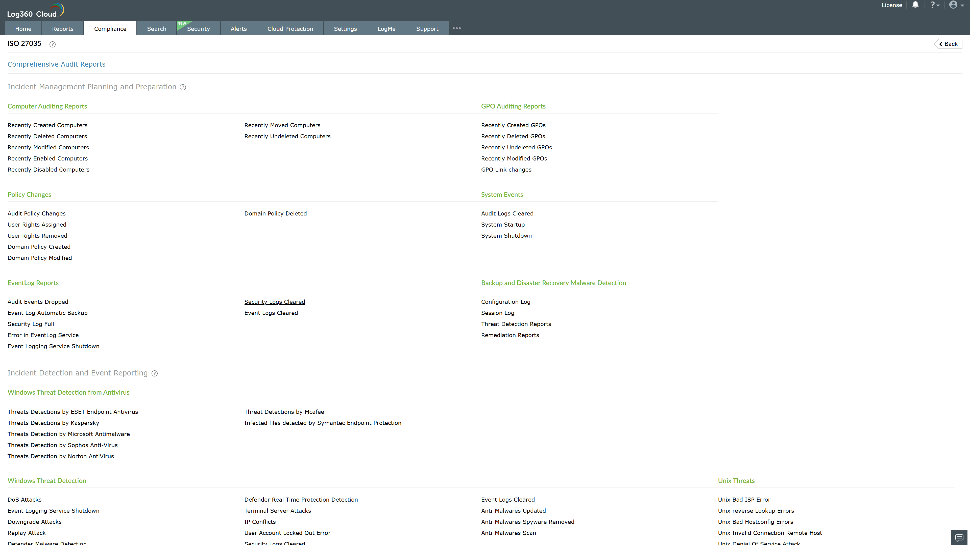
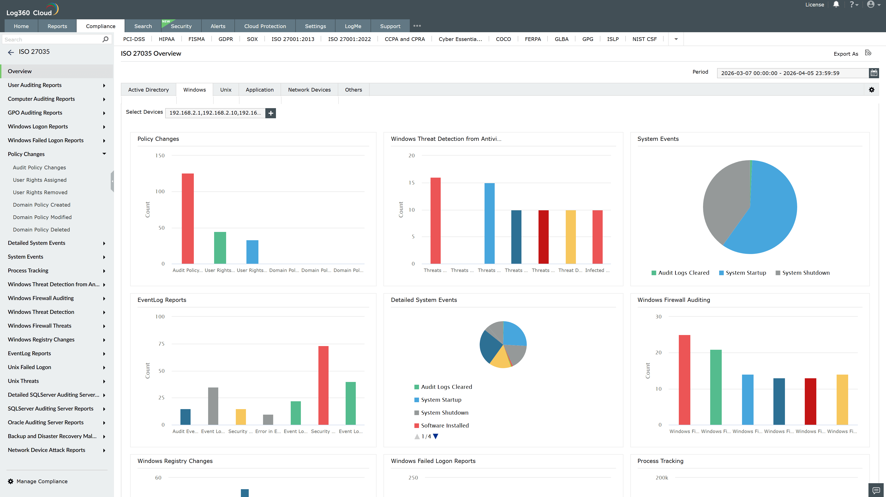
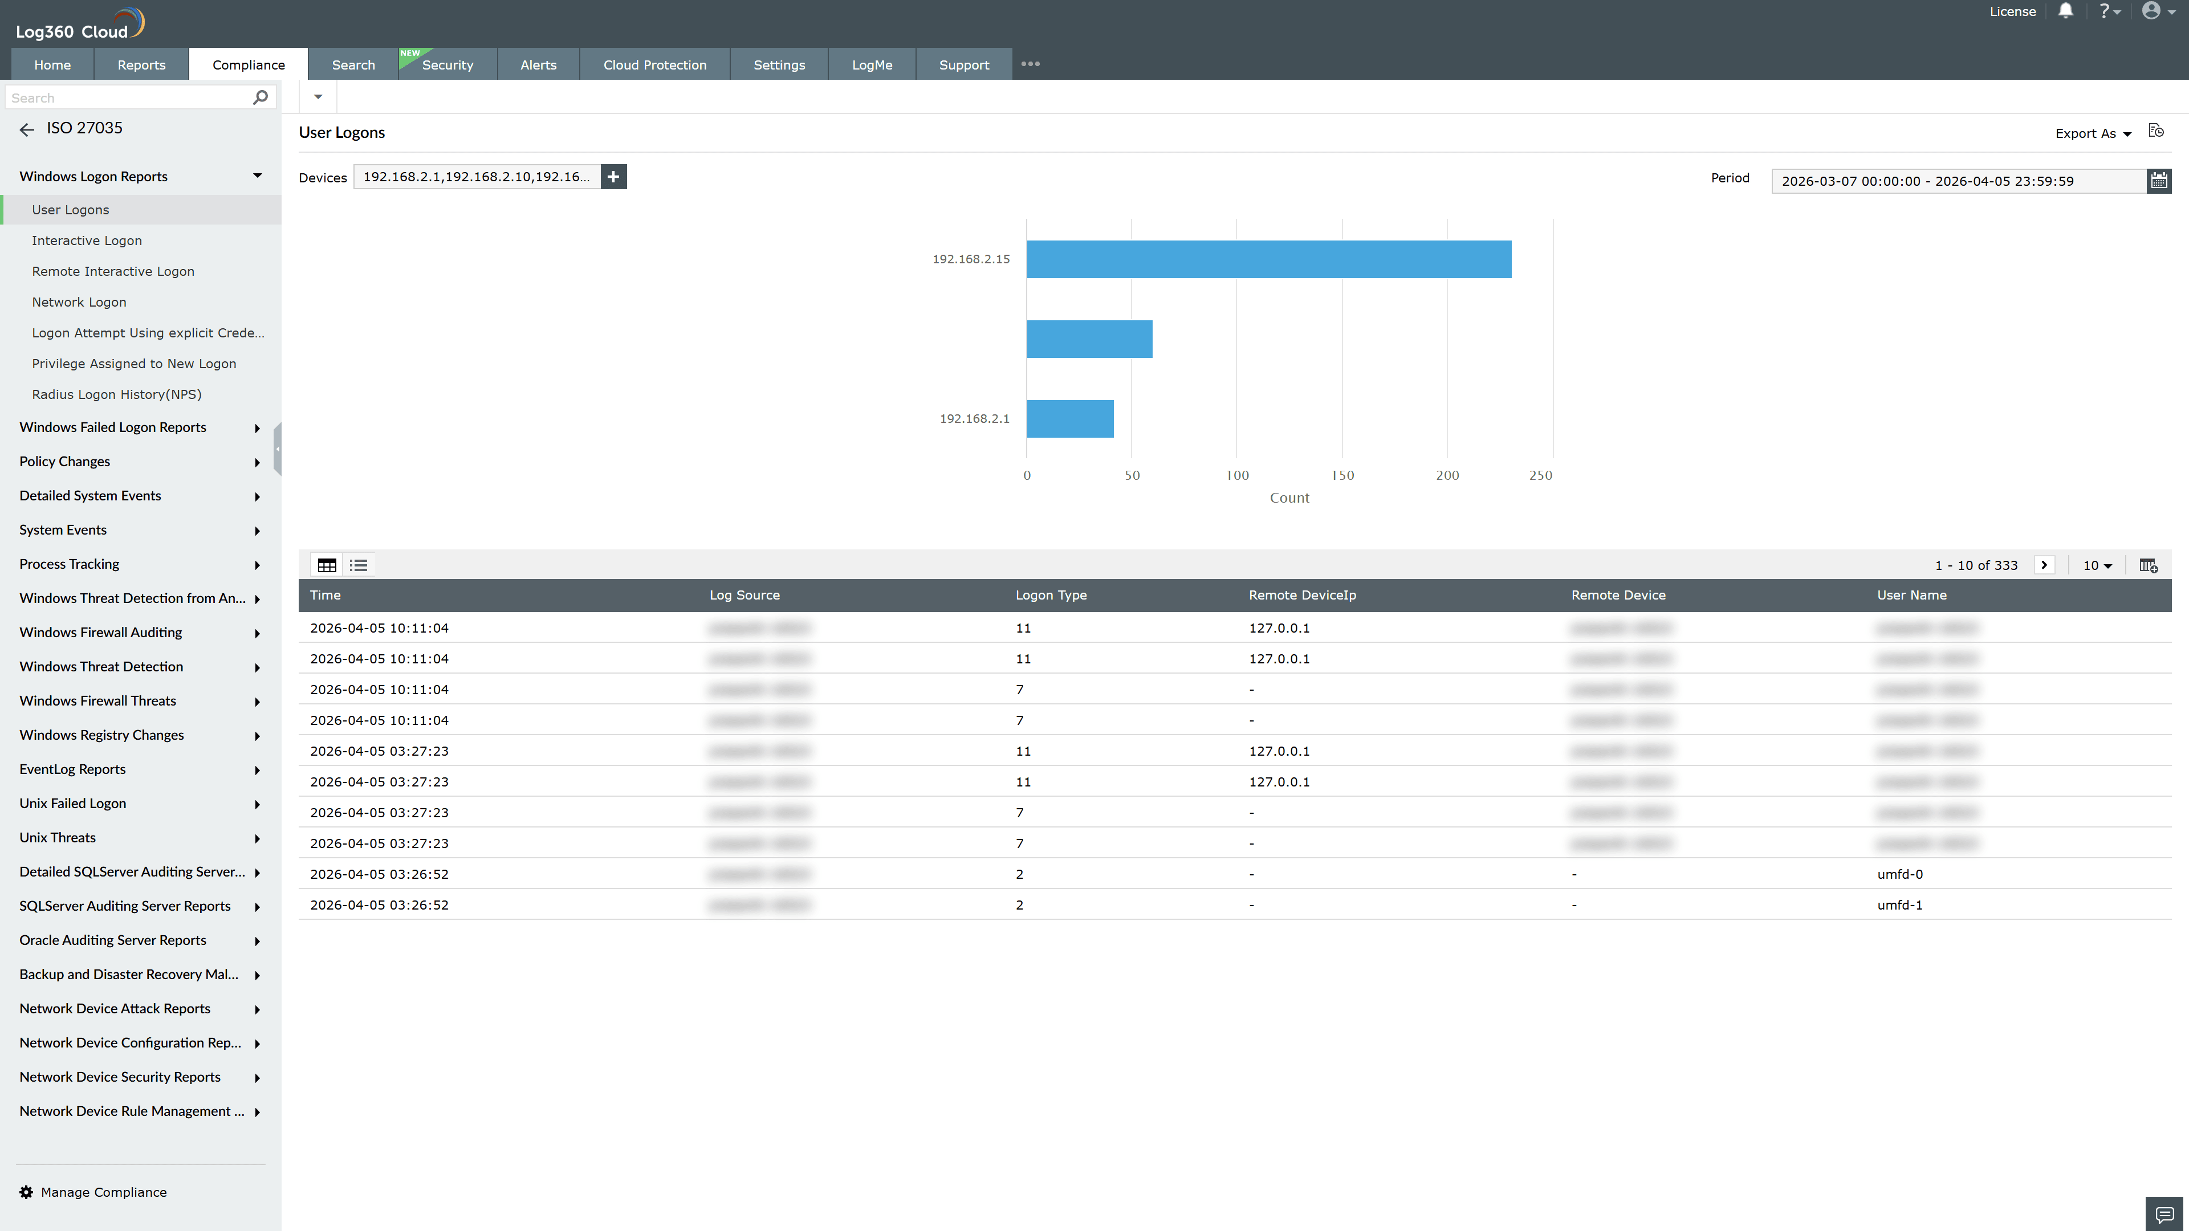
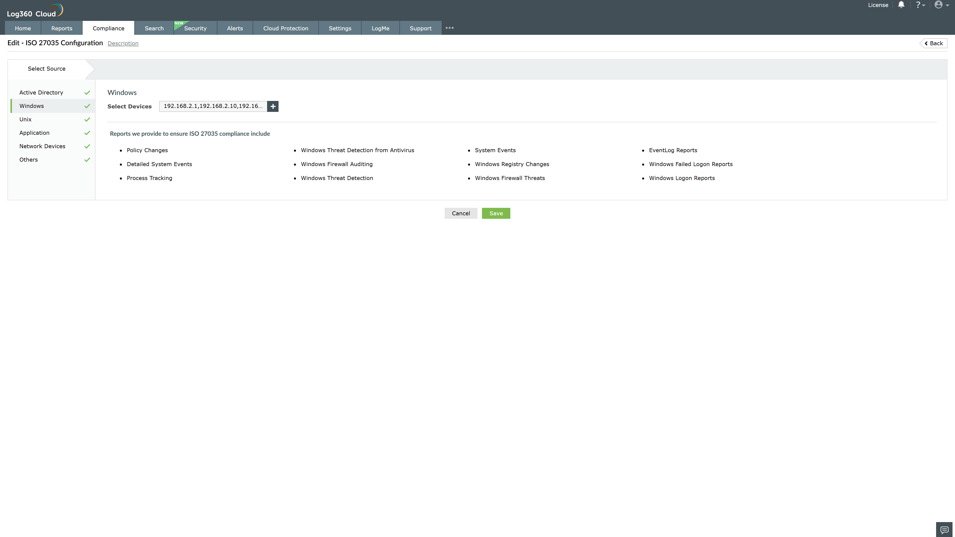
Valid Submission : Yes
Supported Editions : Free, Basic, Standard, Professional, MSSP
Help Document : https://www.manageengine.com/log-management/help/integrations/compliance-extensions.html
Help Video : Not provided
Tags : Log360, Compliance, Privacy monitoring, Data privacy, Regulatory compliance
Supported DCs : US, IN, JP, CA, AU, UK and EU
Privacy Policy:
Terms of Service:
Release Notes:
Predefined reports for the ISO 27035.

